**SPORTIFY INTERFACE DESIGN SAMPLE**

Home

Profile

Update premium

Support

Download

Footer

Postcast

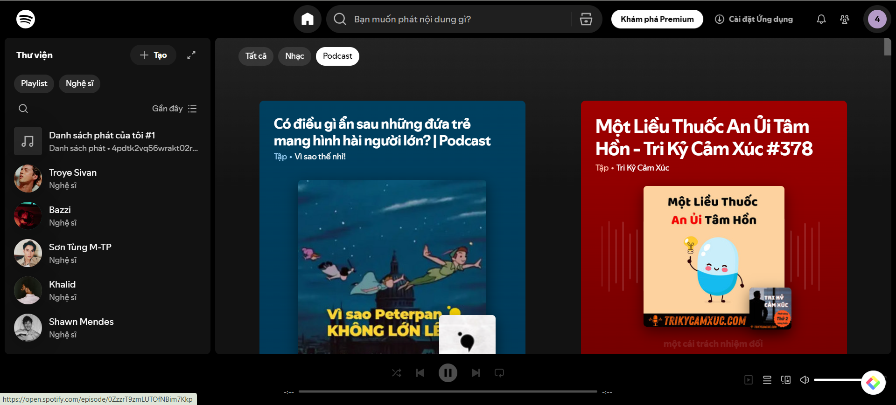

Browse

New release

